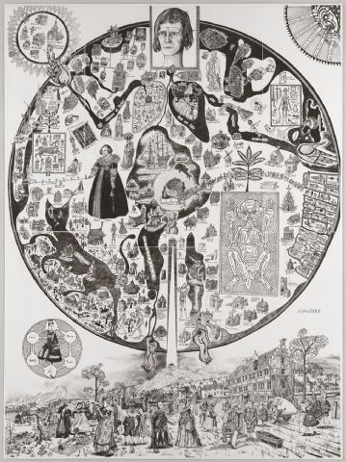
Grayson Perry

TITLE: Map of Nowhere

ARTIST:
Grayson Perry

WORK DATE:
2008

CATEGORY:
Prints

MATERIALS:
Original etching from five plates

EDITION/SET OF:
68

MARKINGS:
Signed and numbered in pencil by the artist on reverse of the sheet.

SIZE:
h: 60.2 x w: 44.5 in / h: 152.9 x w: 113 cm

REGION:
British

STYLE:
Contemporary (ca. 1945-present)

PRICE*:
Contact Gallery for Price

GALLERY:
Galerie Maximillian (970) 925-6100 Send Email

DESCRIPTION:
The third etching by Turner prizewinner Grayson Perry during his career. Created in an edition of 68 impressions and measuring 60 ¼ inches by 44 ½ inches, each print is signed and numbered by the artist.

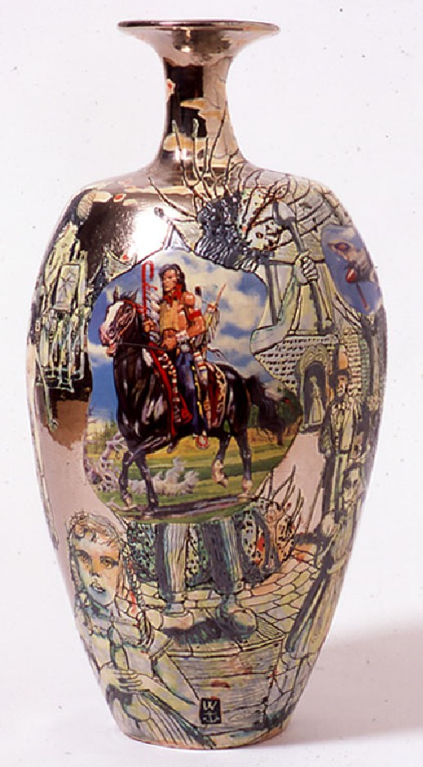
Grayson Perry was born in Chelmsford, Essex in 1960. He studied at Braintree College of Further Education and later at Portsmouth Polytechnic.
In 2003, Perry was awarded the Turner Prize for his exhibitions at the Stedelijk Museum, Amsterdam, and the Barbican Art Gallery, London.
Perry uses the seductive qualities of ceramics and other art forms to make stealthy comments about societal injustices and hypocrisies, and to explore a variety of historical and contemporary themes. The beauty of his work is what draws us close. Covered with sgraffito drawings, handwritten and stencilled texts, photographic transfers and rich glazes, Perry's detailed pots are deeply alluring. Only when we are up close do we start to absorb narratives that might allude to dark subjects such as environmental disaster or child abuse, and even then the narrative flow can be hard to discern. As he says: 'A lot of my work has always had a guerrilla tactic, a stealth tactic. I want to make something that lives with the eye as a beautiful piece of art, but on closer inspection, a polemic or an ideology will come out of it'.

