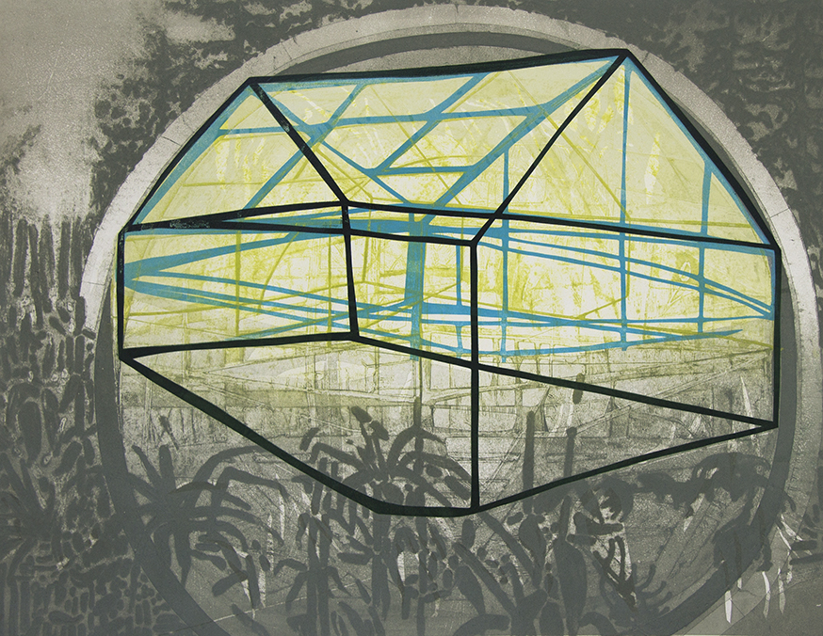Katherine Jones

Blue Frame | 2015 | collagraph and block-print on paper | 80 x 62.5cm

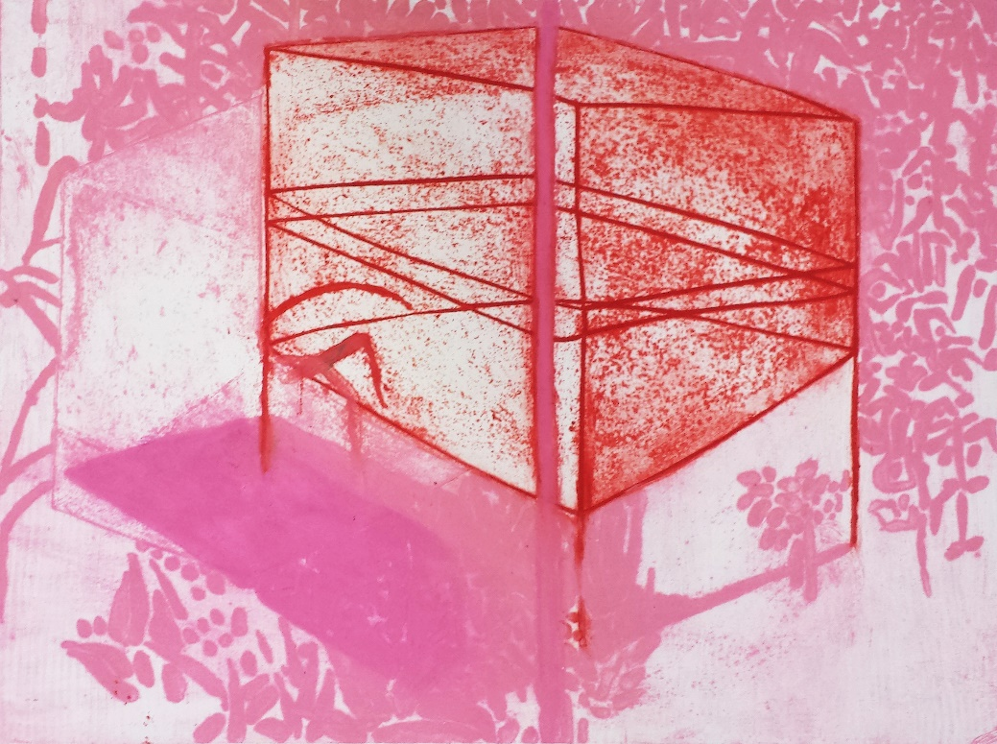

Frame | 2015 | collagraph and block-print on paper | 80 x 59.5cm

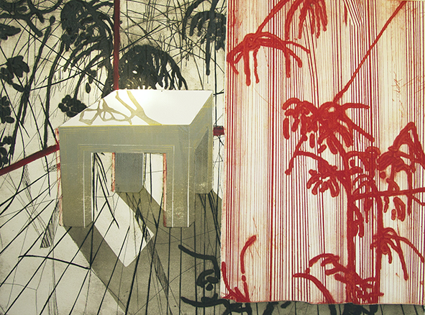

Clear Surface | 2015 | collagraph and block-print on paper | 80 x 59.5cm

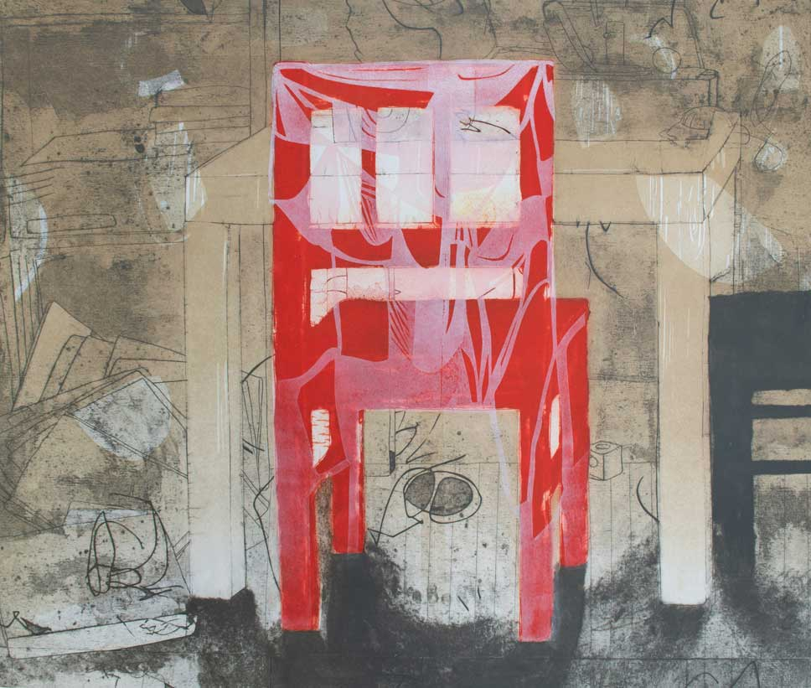

My Child's Chair | 2014 | collagraph and block-print on paper | 83.5 x 69.5cm

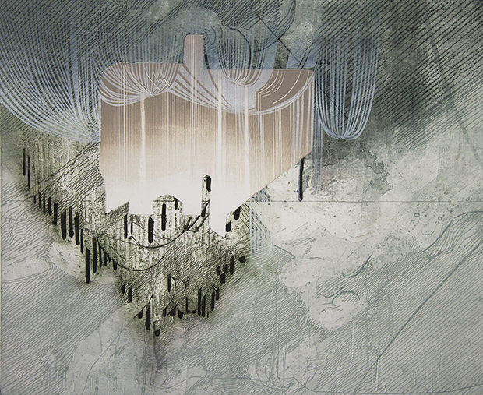

Rain Cloud | 2015 | collagraph and block-print on paper | 82 x 68 cm

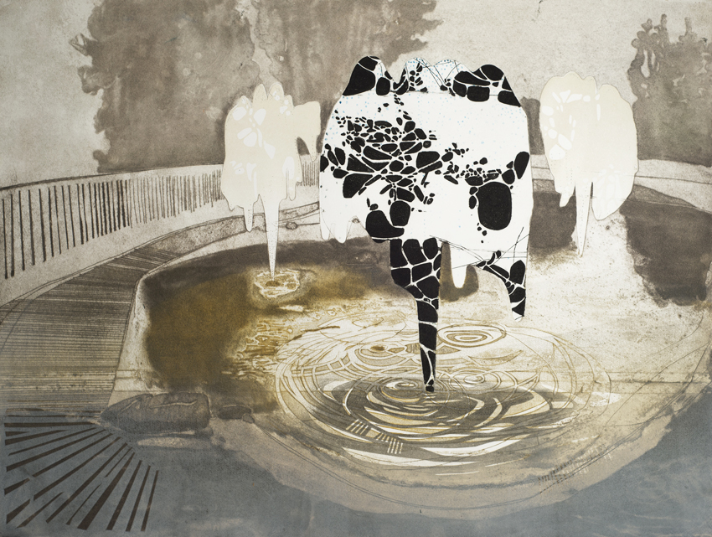

Fountain | 2014 | collagraph and block-print on paper | 75 x 74 cm

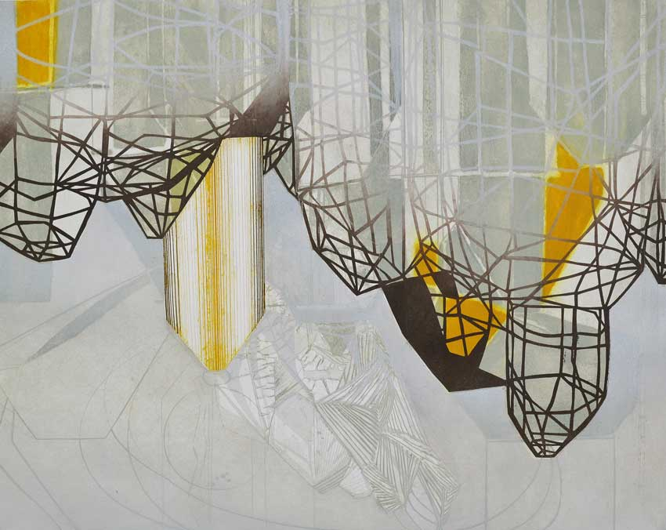A Delimitation of Stripes | 2014 | collagraph and block-print on paper | 86.5 x 72 cm

Commissioned for the Durham Light Infantry Museum for the Glossary: How and Why Artist's Make Prints. Part of the International Print Biennale 2014

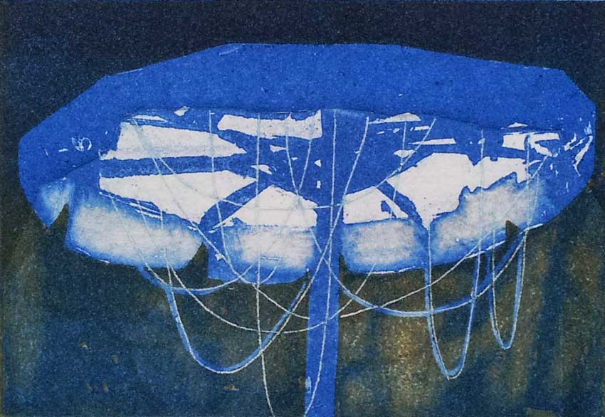**Watch films of all 8 artists here :** [**http://www.alanfentiman.co.uk/glossary**](http://www.alanfentiman.co.uk/glossary)

Parasol | 2014 | etcing and block-print on paper | 10.5 x 7cm

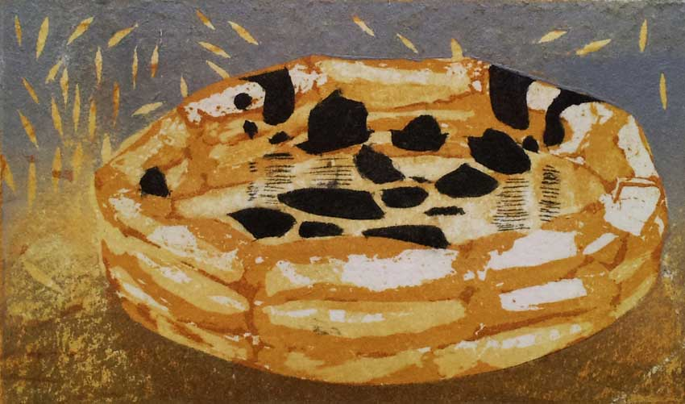

Paddling Pool | 2014 | etching and block-print on paper | 10 x 6cm

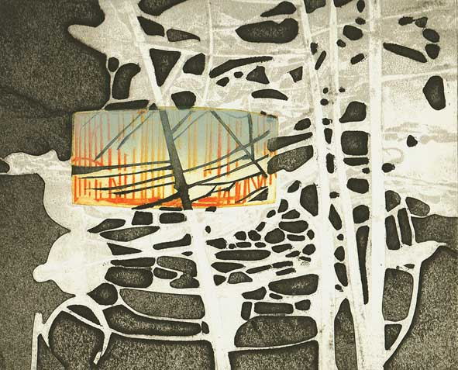

Our Allotted Space | 2012 | collagraph and block-print on paper | 24 x 20cm

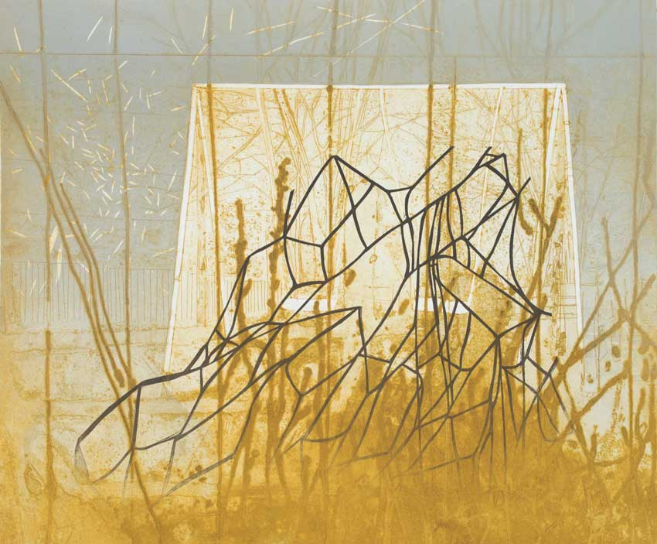

Swings | 2012 | Collagraph and block-print on paper | 86.5 x 72 cm

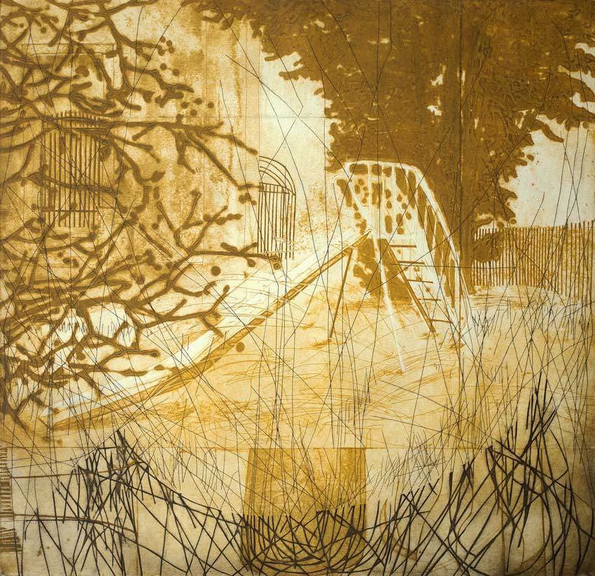

Slide | 2012 | collagraph and block-print on paper | 76 x 74cm

Climbing Beacon | 2012 | collagraph and block-print on paper | 85 x 64cm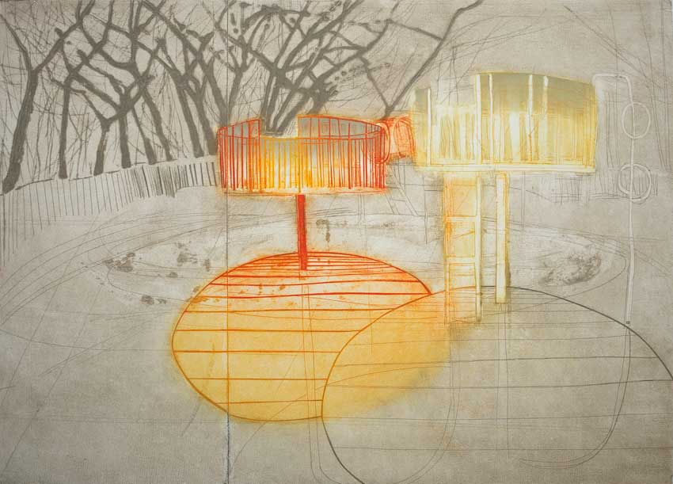

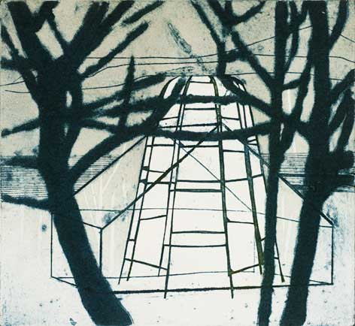

Quiet Town | 2012 | collagraph and block-print on paper | 22 x 20cm

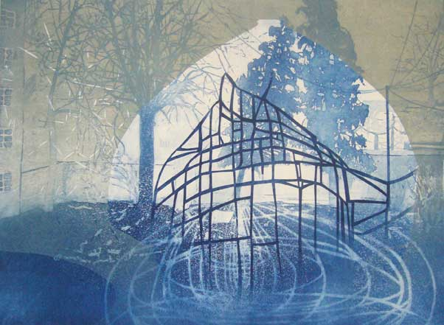

The Belly Pot | 2012 | etching and block-print on paper | 59 x 43cm

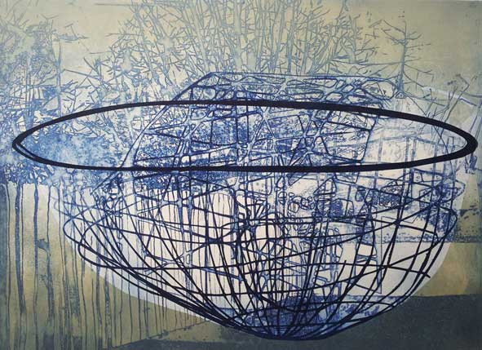

The Lip | 2012 | etching and block-print on paper | 59 x 43cm

[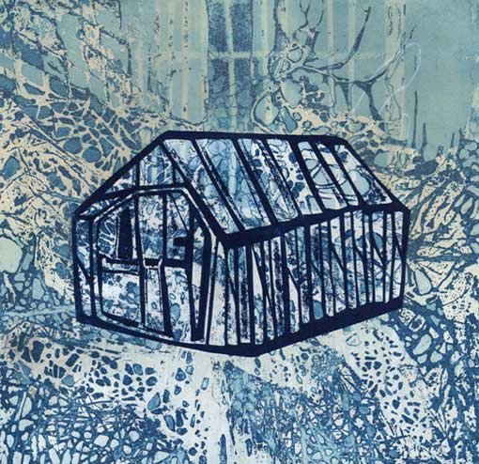](http://www.katherine-jones.co.uk/pages/printmaking/tile.php)

Tile | 2011 | 24 x 24cm | etching and block-print on paper

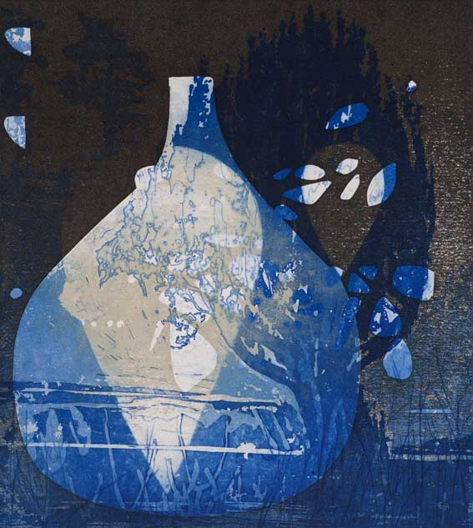Commission for a residency at Kloster Bentlage print workshop in Rheine, Germany in 2011

Tear | 2013 | etching and block-print on paper | 21 x 24cm

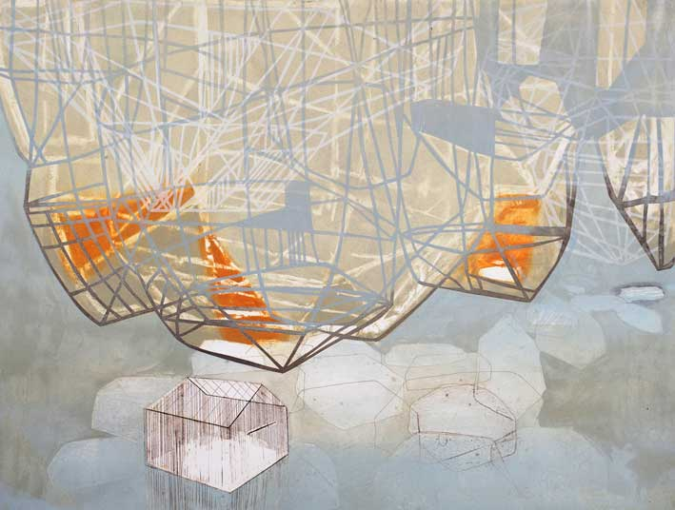

Paper Walled | 2012 | collagraph and block-print on paper | 81 x 63cm

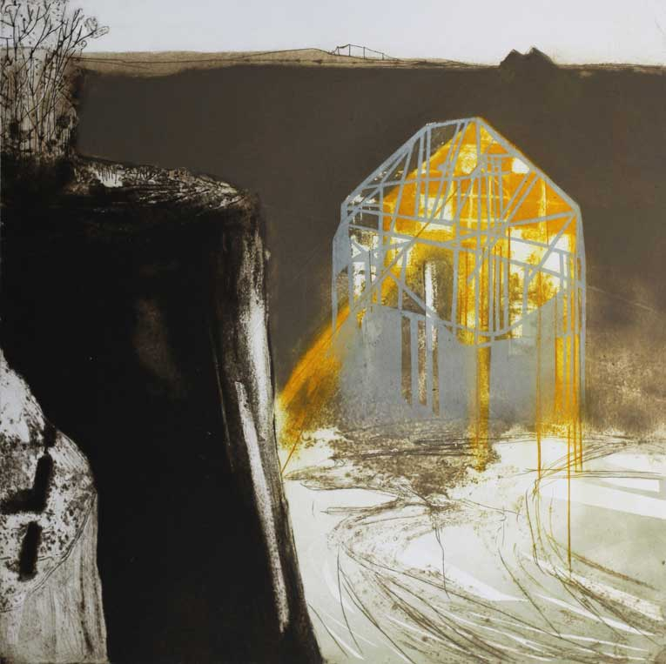

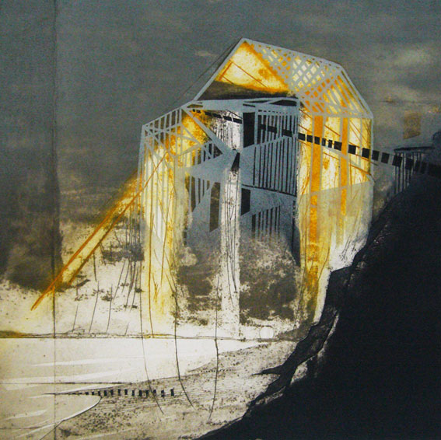

Inside is Dry Land | 2010 | Collagraph and block-print on paper | 50 x 50cm

The Vanishing Land |2010 | Collagraph and block-print on paper | 50 x 50cm

The Usual Things | 2013 | collagraph and block-print on paper

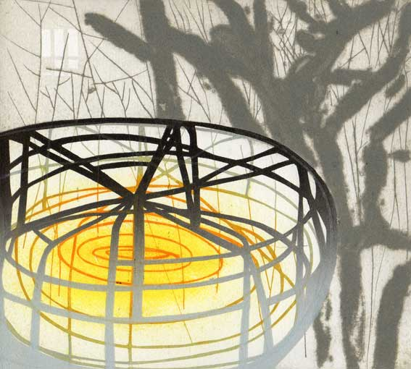Commissioned print for Printfest Residency, Ulverston

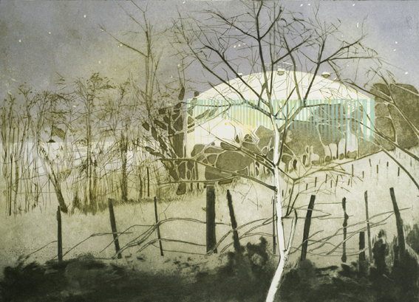

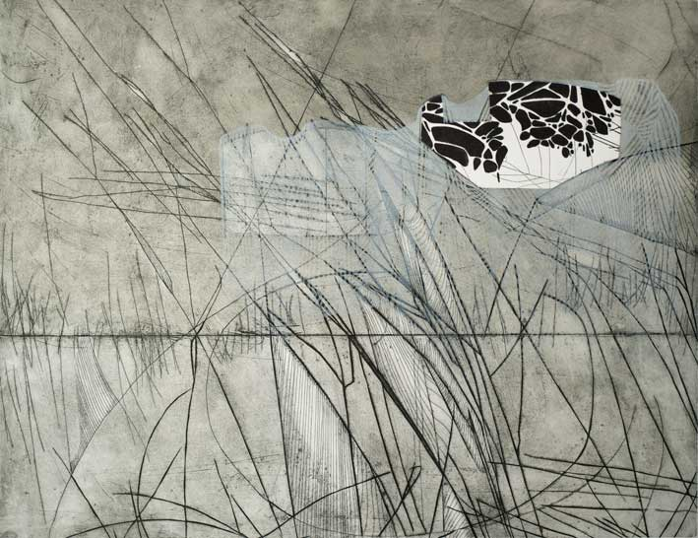Centrifuge | 2012 | collagraph and block-print on paper | 20 x 18cm

Cover and Keep Safe | 2013 | collagraph and block-print on paper | 81 x 63cm

Outpost | 2010 | Collagraph and block-print on paper | 62 x 58.5 cm

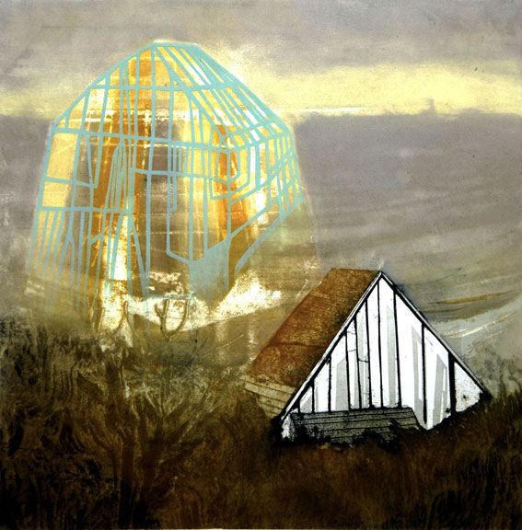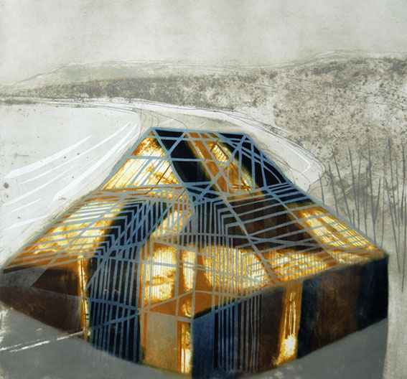

Beach House | 2010 | Collagraph and block-print on paper | 50 x 50cm

Stove | 2008 | Etching and collagraph on paper | 20 x 24cm

The title is a reference to John Paxton's 'Great Stove', a hothouse built and designed for the gardens of Chatsworth House in the 1800s which was later dismantled.

Paxton also designed and built The Crystal Palace in Hyde Park for The Great Exhibition. It was then moved to Sydenham and was destroyed by fire in 1936.

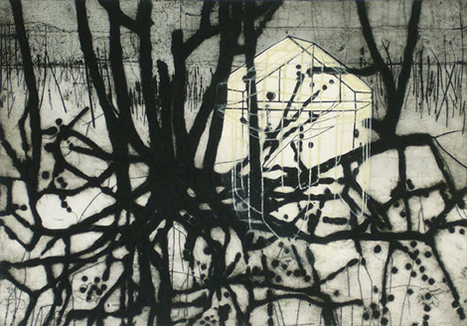

Roots |2009 | Collagraph and block-print on paper | 53.5 x 37.5cm

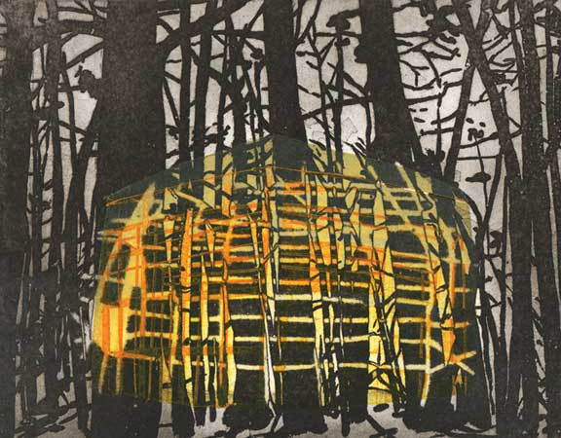

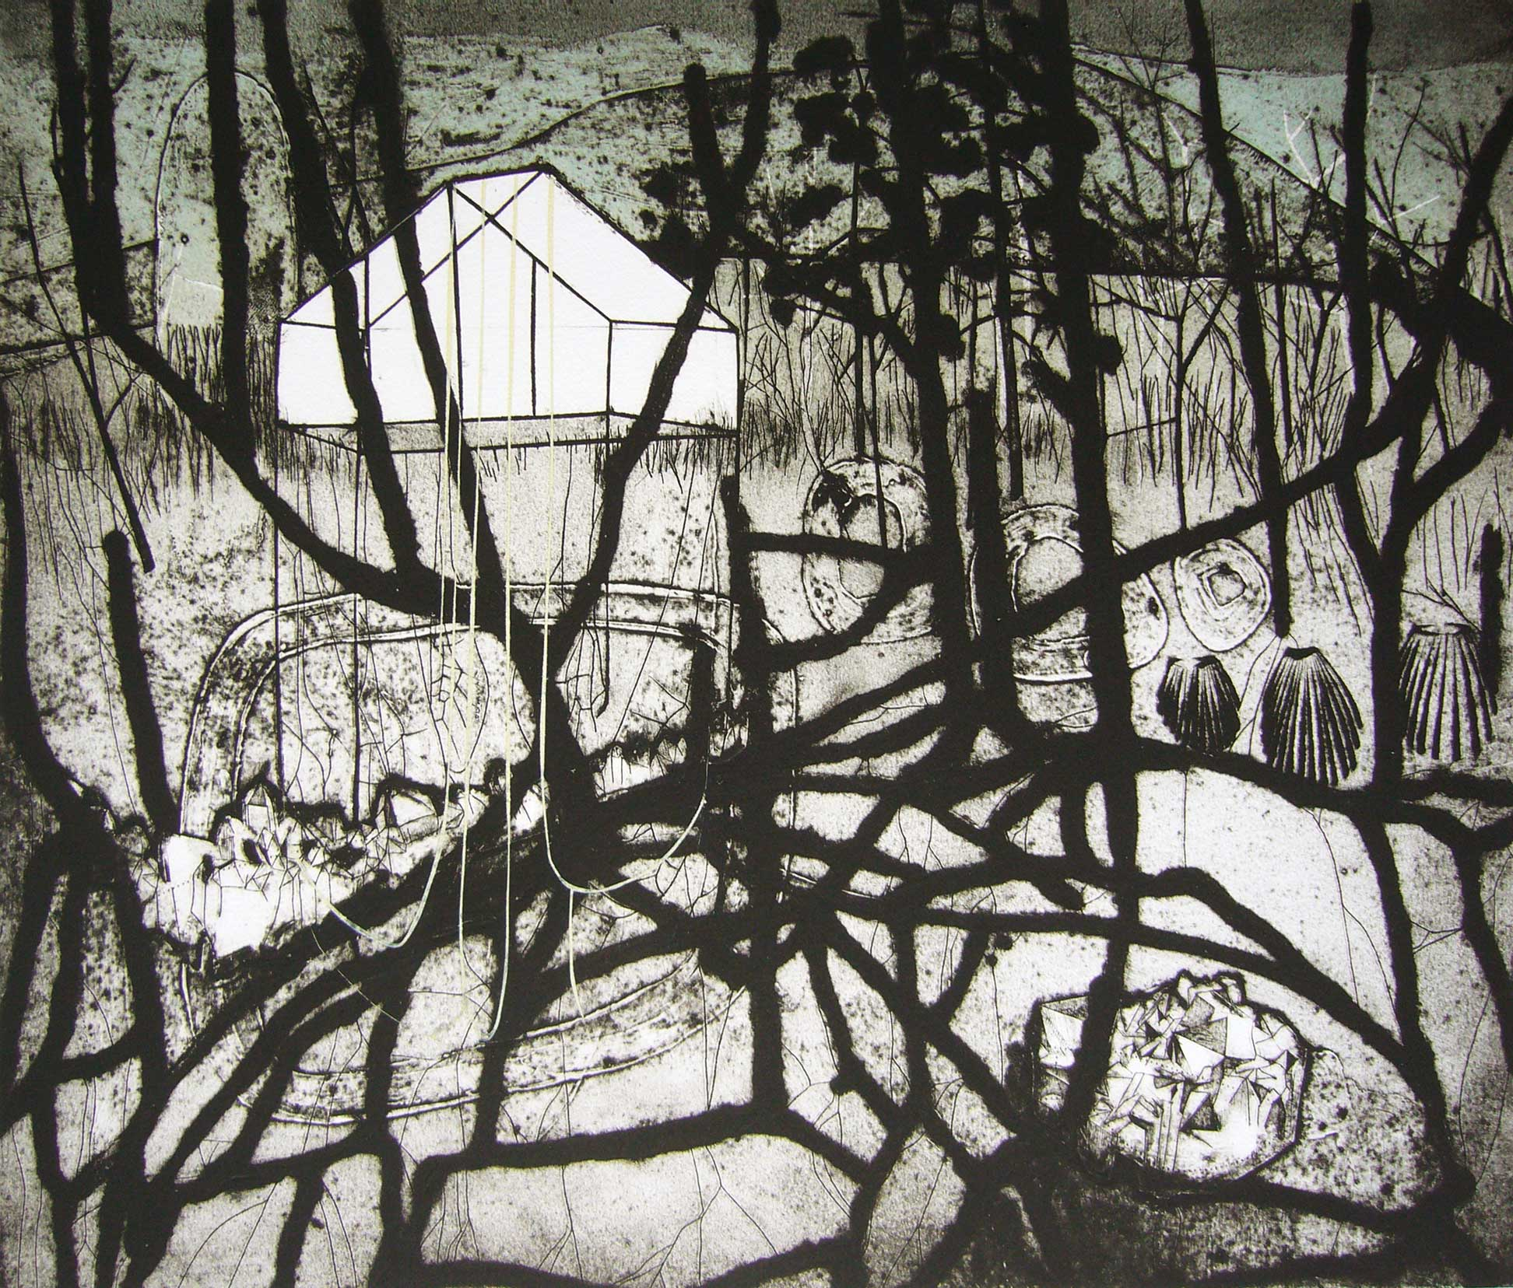

High Light Bell | 2009 | Collagraph and block-print on paper | 58.5 x 50.5cm

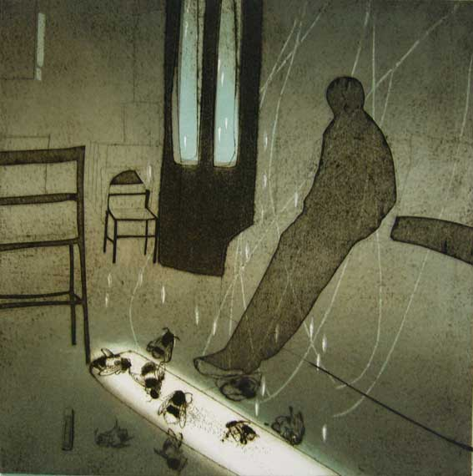Hammersmith Angel | 2006 | Collagraph on paper | 36 x 37cm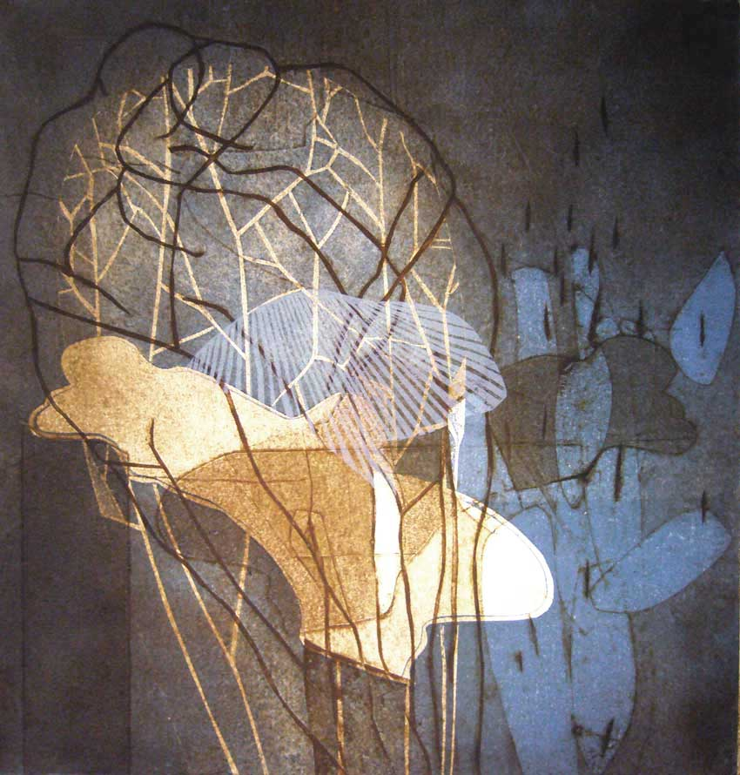

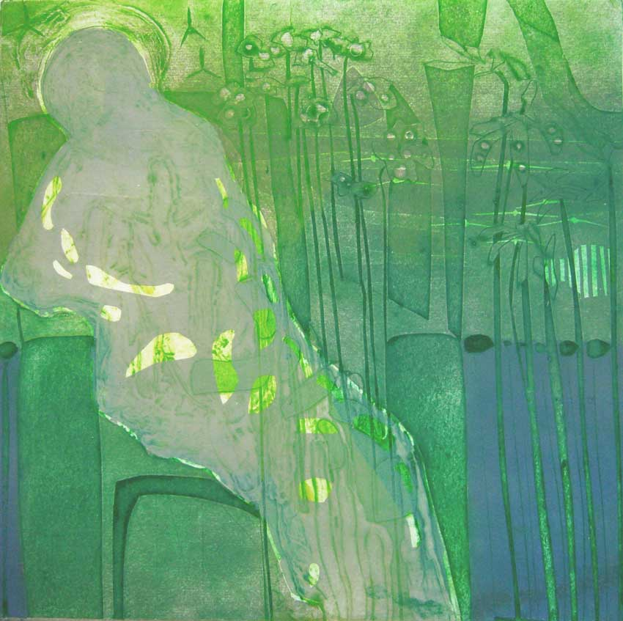Bumble Bee Grey | 2007 | Collagraph on paper | 32 x 32cm

Mary F's Garden | 2006 | Collagraph on paper | 30 x 30cm

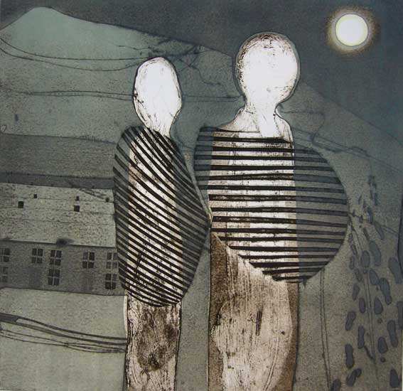The Present | 2006 | Collagraph on paper | 34 x 34cm

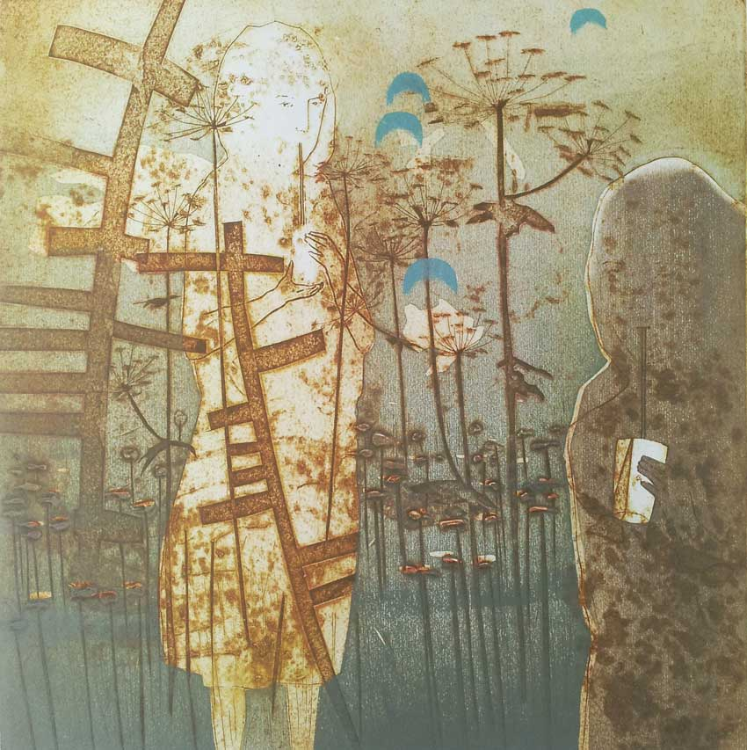

The Old Space | 2006 | Collagraph on paper | 40 x 39cm

This Quiet | 2007 | Collagraph on paper | 42 x 42cm

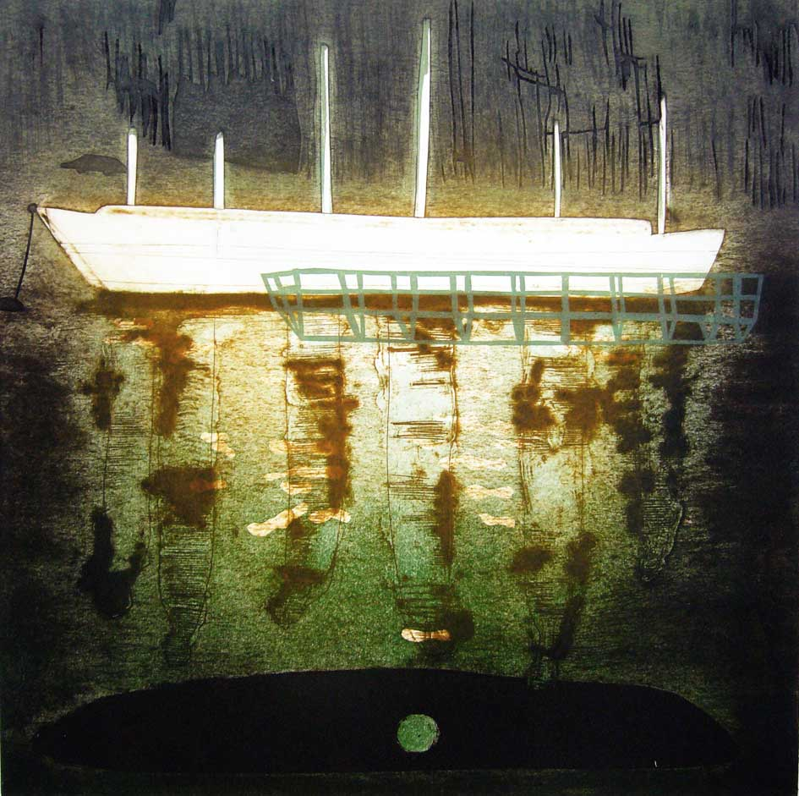

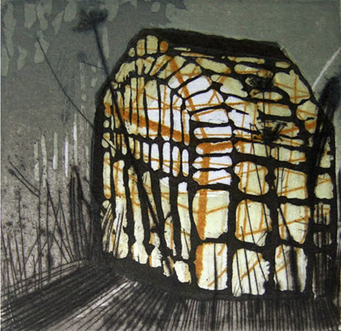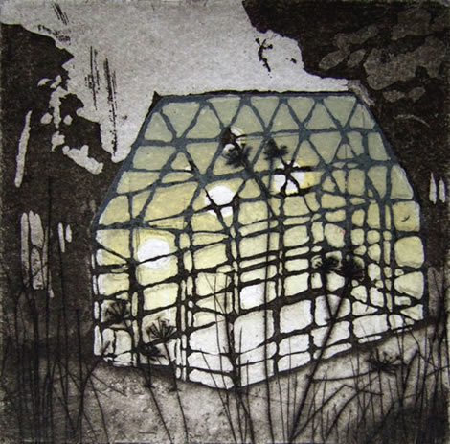

Greenhouse No.1 | 2009 | Etching and block-print on paper | 8 x 8 cm

Greenhouse No.3 | 2009 | Etching and block-print on paper | 8 x 8 cm

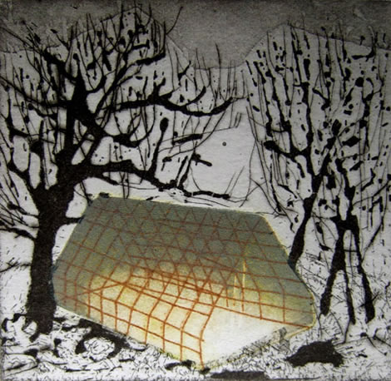

Greenhouse No.2 | 2009 | Etching and block-print on paper | 8 x 8 cm

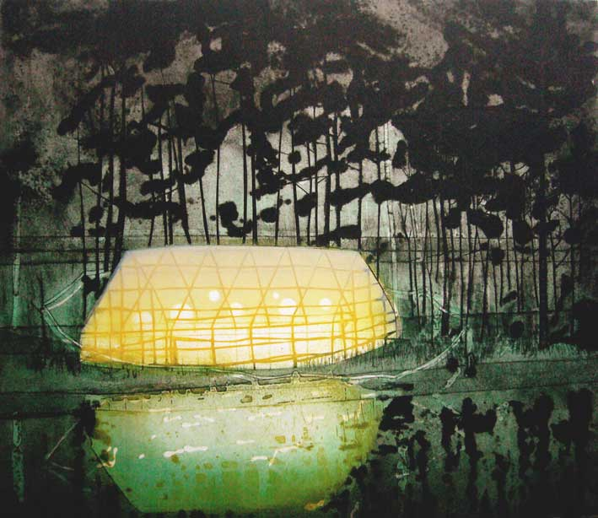

A House In The Woods | 2007 | Collagraph on paper | 50 x 58cm

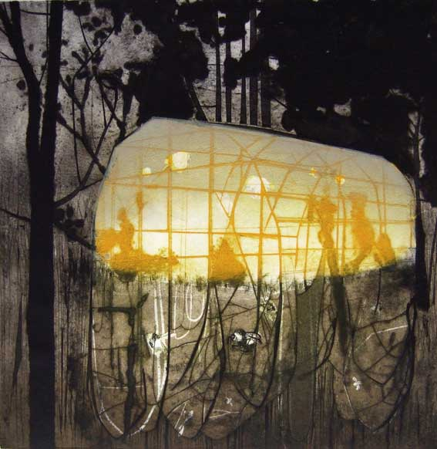

The Propagation of Sound | 2008 | Collagraph on paper | 40 x 40cm

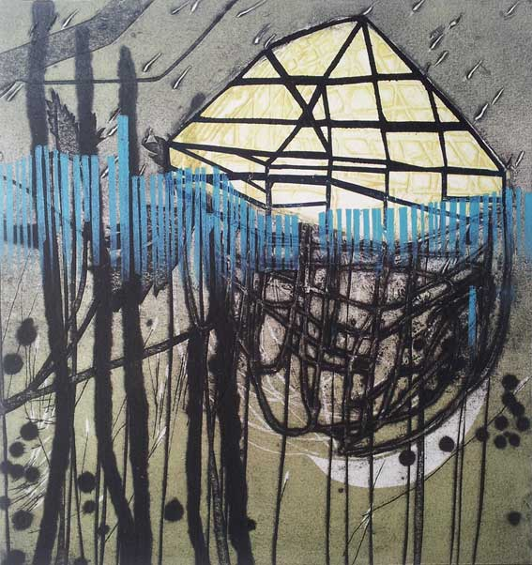

Buried Haven | 2010 | Collagraph and block-print on paper | 37 x 36cm

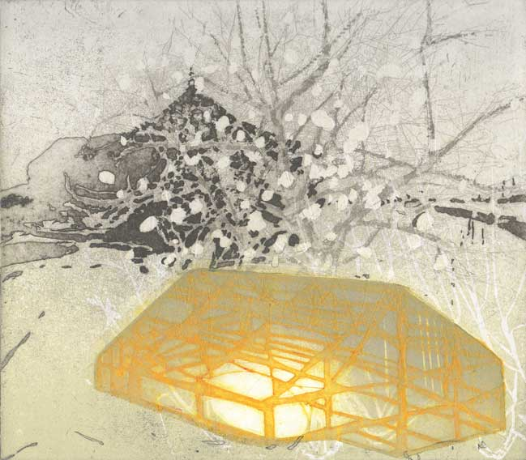

A Surrender To Impulse | 2007 | Collagraph etching and block-print on paper | 20 x 24cm

An Old Friends House | 2007 | An Old Friends House | 20 x 24cm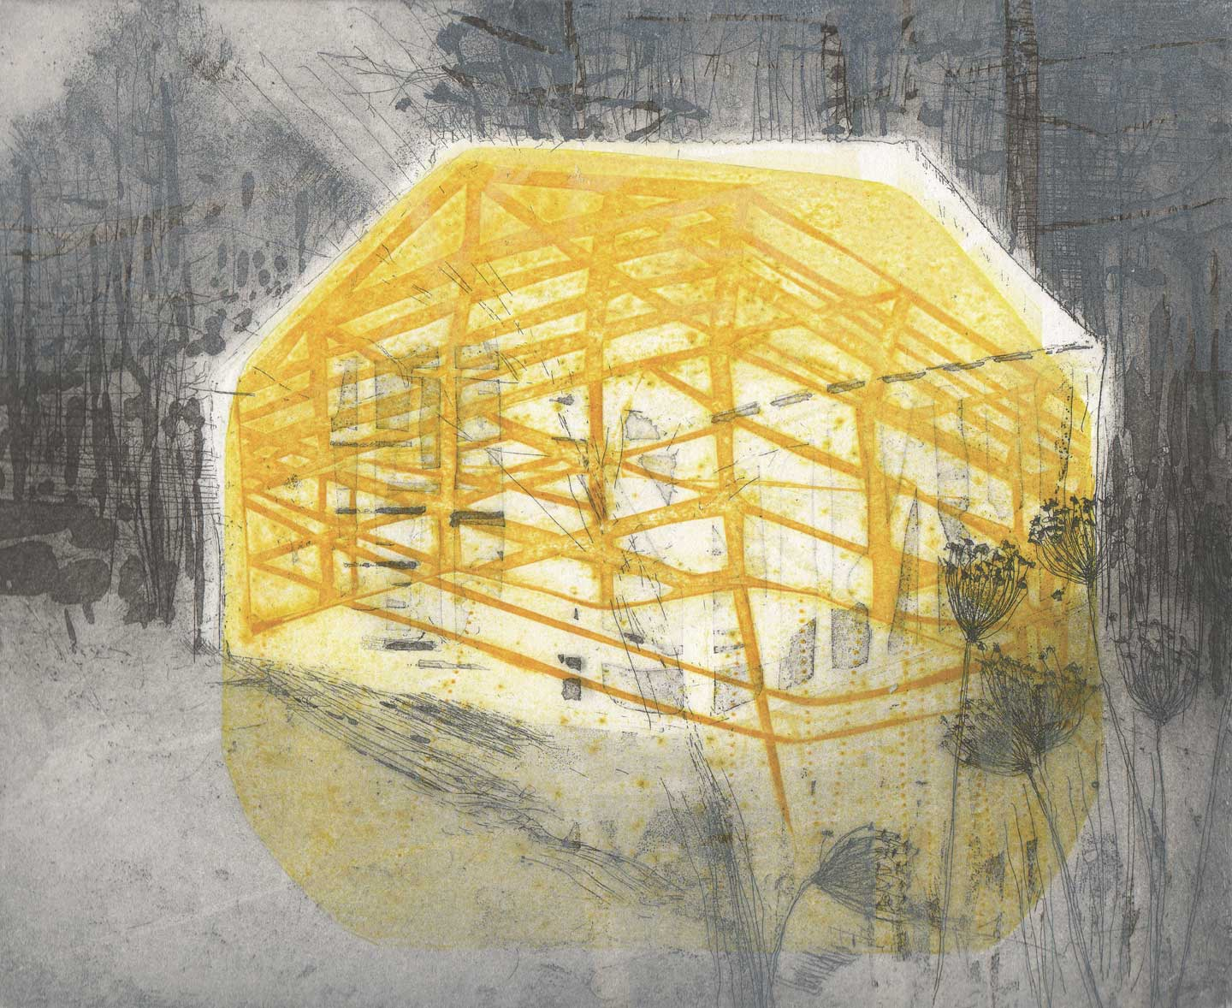

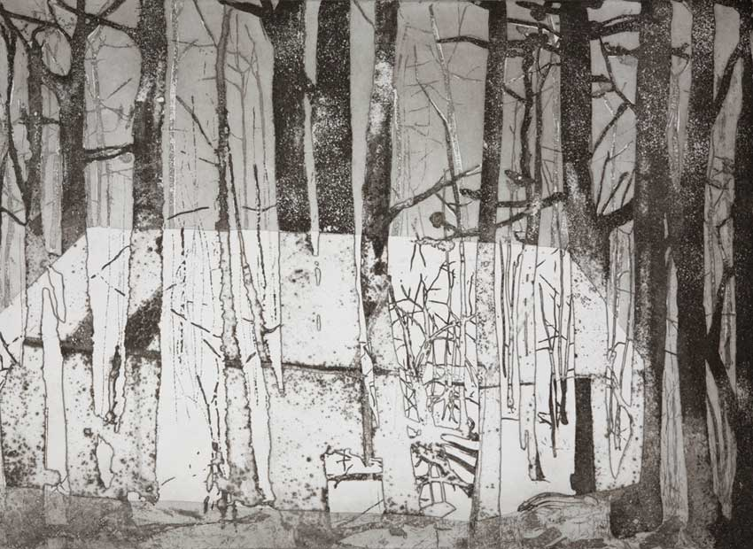

Refuge | 2008 | Etching and sugarlift on paper | 59 x 43cm

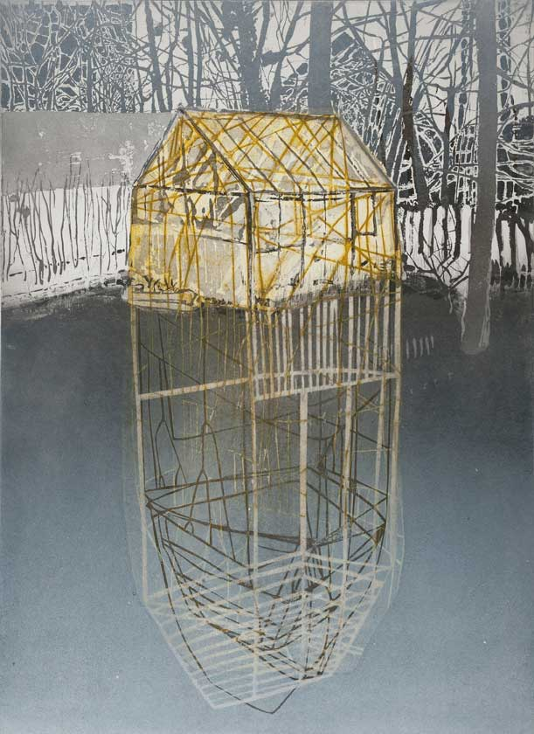

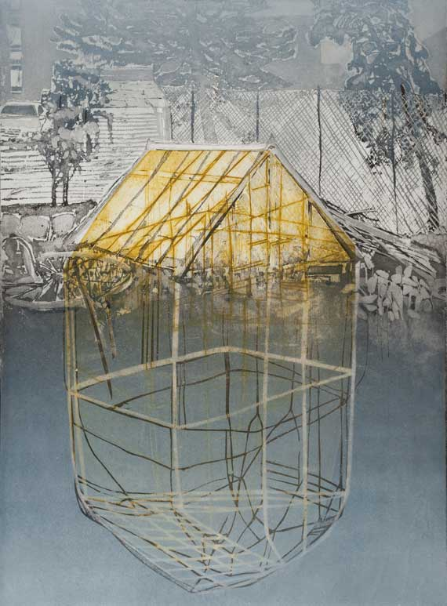

Paxton's Glass House No.1 | 2010 | Etching and block-print on paper | 59 x 43cm

Paxton's Glass House No.2 | 2010 | Etching and block-print on paper | 59 x 43cm

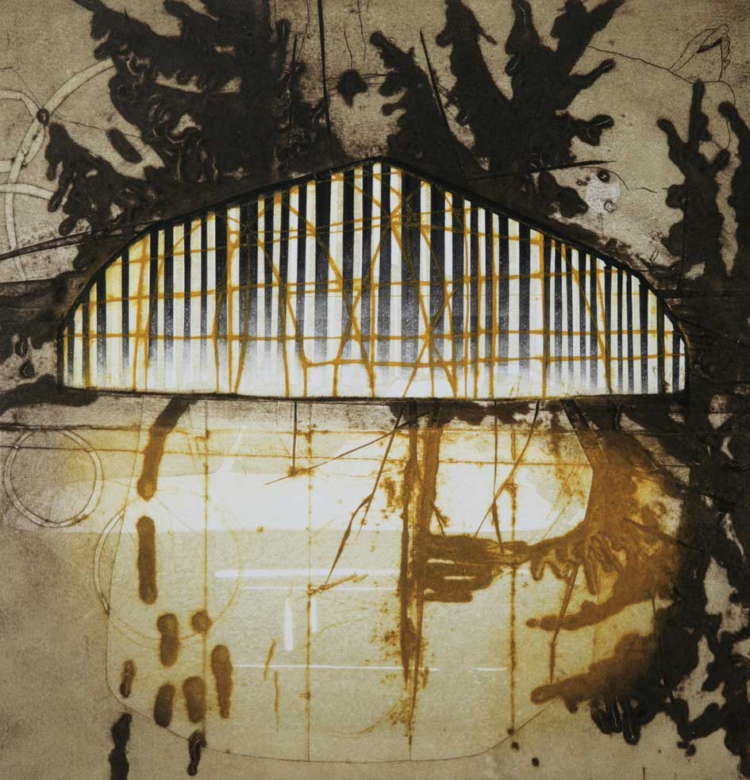

The Water Margin | 2009 | intaglio and block-print on paper | image size 35 x 36cm

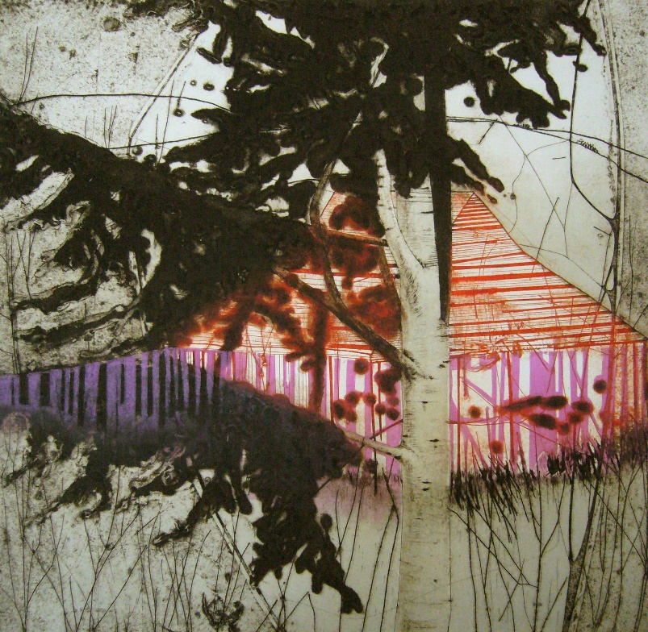

Magenta Strip | 2009 | collagraph and block-print on paper | image size 36 x 37cm