DESIGN
Pictorial & Technical Conventions

Airbrush  Using airbrush (or spray guns) to create smooth blending or other effects | 
Anime  Japanese cartoon style | 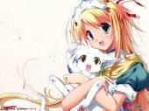
Appropriation  Incorporating images from the media, art works, or other existing sources into one’s own work | 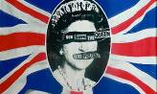
Autonomous / Accident / Chance  Images or arrangements that are determined by chance such as doodles or rolling a dice to choose visual elements | 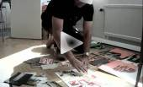
Branding  Cohesive visual and informational styling | 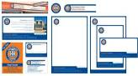
Line - The quality of line e.g. straight, curved, broken, elastic, organic, geometric etc | 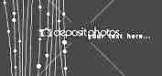
Digital  Computer generated imagery that may include Photoshop manipulation of mechanical production processes such as projection or paint machines | 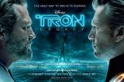
Moodboard  Collection of images relating to a them or style | 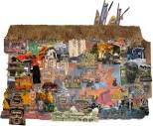
Multimedia  Combining different materials together | 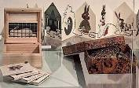
Pop-Up | 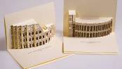
Storyboard  Planning sequence of images that communicate a narrative | 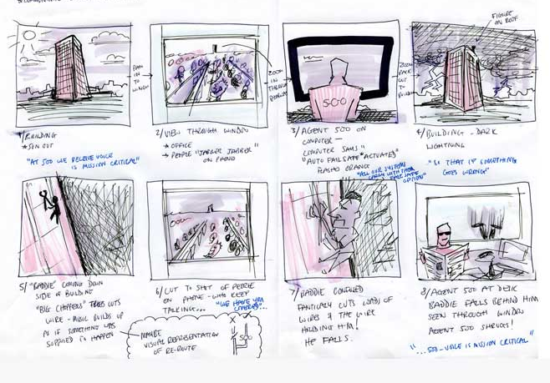
Target Audience
The client focus will affect the style and content of the outcome – sub culture, specific profession, ethnicity, gender, age, religion, etc
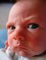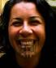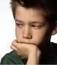

Tone  Bleached out pastel shades through to dark sombre mysterious shadows | 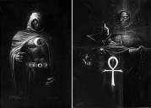
Vinyl  Cut out shape of (often self adhesive) material used to create images | 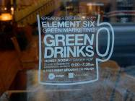
Zine  Limited edition, sometimes hand made, magazine. | 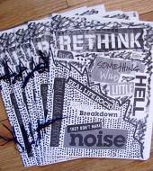

AIM / INTENTION  Message | Advocacy | 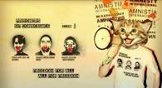
AIM / INTENTION  Message | Educational
AIM / INTENTION  Message | Entertainment
AIM / INTENTION  Message | Humour | 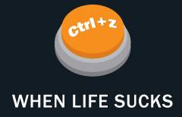
AIM / INTENTION  Message | Informational | 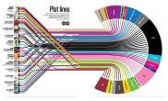
AIM / INTENTION  Message | Political | 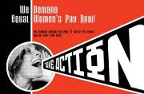
AIM / INTENTION  Message | Promotional | 
AIM / INTENTION  Message | Public Health | 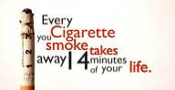

Briefs  Particular project | Architectural / Interior | 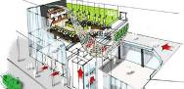
Briefs  Particular project | Badge  Billboard  Business Card  Brochure | 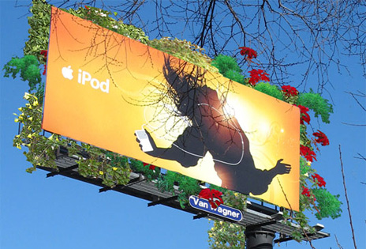
Briefs  Particular project | CD or DVD (Disk Graphics & Booklet)  Costume (Theatre, Wearable Art)  Cover (Magazine, Book) | 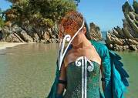
Briefs  Particular project | DPS (Double Page Spread) | 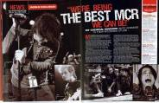
Briefs  Particular project | Flyer  Graphic Novel  Illustration | 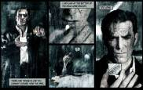
Briefs  Particular project | Lanyard  Logo | 
Briefs  Particular project | Masthead | 
Briefs  Particular project | Packaging  POS Display (Point of Sale) | 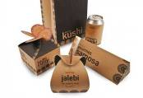
Briefs  Particular project | Poster  Product (3D) | 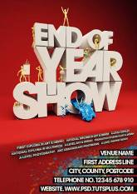
Briefs  Particular project | Set Design  Vehicle Graphics  Video Game (Characters and Environment) | 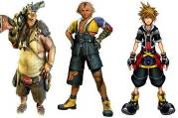
Briefs  Particular project | Website | 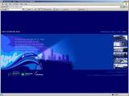

COLOUR | Colour Separation – | 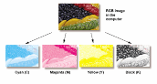
COLOUR | Complimentary Colour - Colours opposite on the colour wheel (green/red) placed side by side to enhance their intensity | 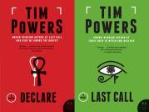
COLOUR | Flat Colour – No blending or texture
COLOUR | Greyscale | 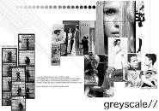
COLOUR | Local Colour - The true colour – natural, unmodified. | 
COLOUR | Monochrome - Single colour | 
COLOUR | Polychrome - multiple colours | 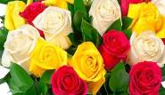

IMAGE Source | Collage / Montage | 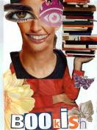
IMAGE Source | Hand Made / Drawn | 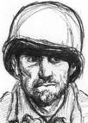
IMAGE Source | Pattern – found or created  Texture – found or created | 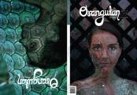
IMAGE Source | Paper Cut-out | 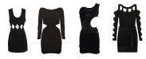
IMAGE Source | Photographic | 

IMAGE STYLE | Abstract - Pure colour/texture/form – not depicting a recognisable object | 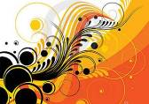
IMAGE STYLE | Grunge / Graffiti | 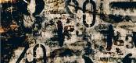
IMAGE STYLE | Pixilation | 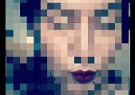
IMAGE STYLE | Posterised – Reduced to a series of flat colours | 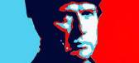
IMAGE STYLE | Silhouette - Flat usually black shape rather than a rounded object. All detail is removed. | 
IMAGE STYLE | Stylised - Changing the appearance of the subject but still being recognisable - eg simplified, exaggerated or distorted | 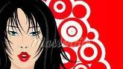
IMAGE STYLE | Transparent / Opacity / Overlay | 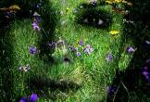

Layout  The arrangement of design elements – text, image, etc | Grid - Paintings implicitly or explicitly arranged in a grid formation. | 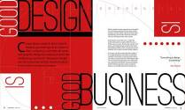
 | Gutter – Fold between pages - text elements cannot be read
 | Framing - Using natural or drawing elements to frame or contain objects or scenes | 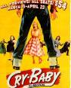
 | Insert - The inclusion of a different picture within a picture. | 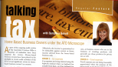
 | Juxtaposition - Placing two images next two each other to create meaning through association.
 | Negative Space - The empty areas between objects | 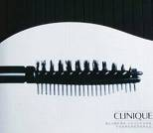
 | Repetition - Repeating a visual elements to create an effect or rhythm | 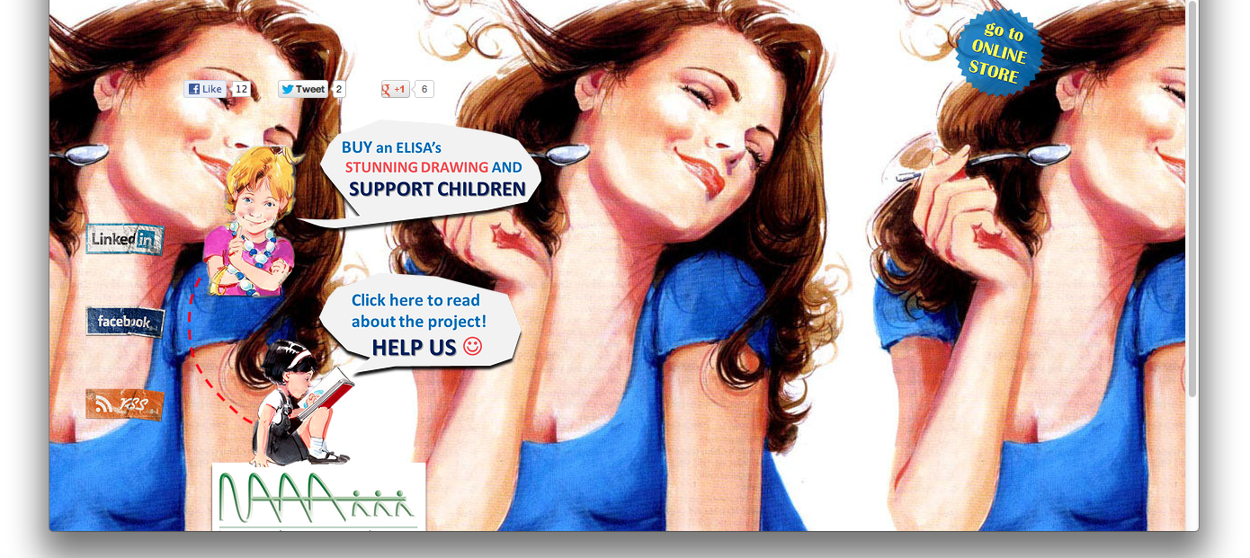
 | Symmetry - Balancing elements on either side of the centre line | 

Typographic Conventions | Case – Upper or lower | UPPER lower
Typographic Conventions | Font – Arial, Helvetica, Times New Roman | Arial, Bauhaus, Mistral, Times New Roman
Typographic Conventions | Hierarchy – Most important word being more prominent | 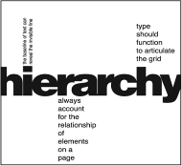
Typographic Conventions | Style – Bold, Italics, Heavy Bold, Light | Bold, Italics, Narrow, Heavy Bold
Typographic Conventions | Kerning – Space between letters | Ke r n i n g
Typographic Conventions | Leading – Space between lines | Leading leading leading leading  Leading leading leading leading  Leading leading leading leading
Typographic Conventions | Effects – Stroke, Emboss, Drop Shadow, Transparent | 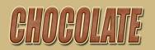
Typographic Conventions | Layout – Stacking, separate objects | 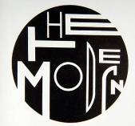
Typographic Conventions | Transform – Distort, Skew, Arc | 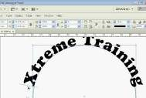
Typographic Conventions | Stress – Fragment, Grain, Stain, Erase | 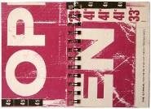
Typographic Conventions | Inserted Image | 
Typographic Conventions | Hand Made and 3D | 