Painting Pictorial & Technical Conventions

Abstract  Pure colour/texture/form – not depicting a recognisable object | 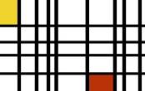
Aerial Perspective  Objects become more blurry and bluish as they are positioned further into the distance | 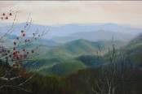
Appropriation  Incorporating images from the media, art works, or other existing sources into one’s own work (Douglas Kolke, David Salle) | 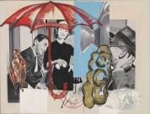
Blending  Smooth graduation of two wet colours from one to the other | 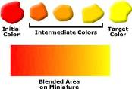
Cast Shadow  The shadow thrown on a surface by some object that is interposed between it and the light | 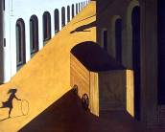
Chiaroscuro  (ki-är'os-cu'ro) -The art of distributing the lights and shades of a picture | 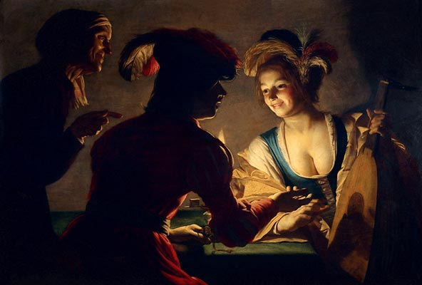
Complimentary Colour  Colours opposite on the colour wheel (eg green/red) placed side by side to enhance their intensity | 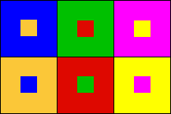
Collage  Including real flat elements into a work – printed images, wallpaper etc | 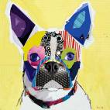
Craquelure  Fine pattern of dense "cracking" formed on the surface of materials | 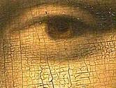
Diptych  Also triptych, quartet, series and suite of work. Where more than one separate painting is intended to be seen as a single work. | 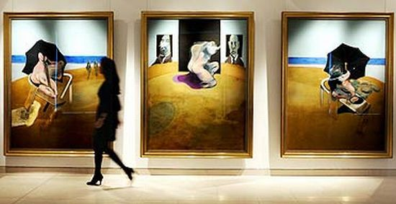
Foreshortening  Perspective device used for anatomic work where body parts get proportionally larger as they approach the viewer | 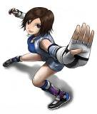
Foreground Middleground Background  Areas of the painting in relation to the viewer | 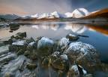
Frottage  Rubbing the back of a paper over a textured surface to gain an impression | 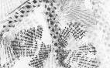
Genre  Style, theme or subject matter – Portrait, self-portrait, landscape, seascape, still life, vanitas, abstract, hard edge, colour field, minimalism, fantasy, fluxus, lowbrow, digital, performance, telematic, conceptual, Pop, Cubist, Dada, Classical, formal, expressive, Neo-Expressive, pattern making, graffiti, mural, installation | 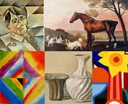
Glazing  Putting a transparent colour over other colours, either to increase or decrease their brilliancy without changing the effect of light and shade | 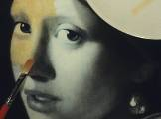
Grid  Paintings implicitly or explicitly arranged in a grid formation. | 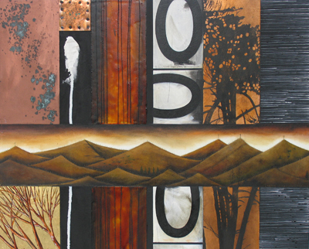
Hatching and Crosshatching  The use of the brush or pencil so as to make lines that cross each other at regular intervals | 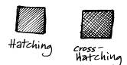
Iconography  Objects that represent ideas – eg a dove symbolising peace | 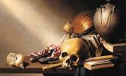
Impasto  Thick textural brush stokes | 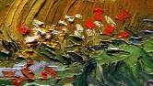
Insert  The inclusion of a different picture within a picture. Often the juxtaposing of the two image creates a meaning | 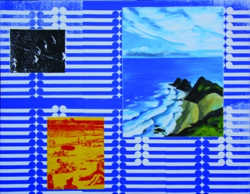
Juxtaposition  Placing two images next two each other to create meaning through association. Hairdryer, and nuclear bomb | 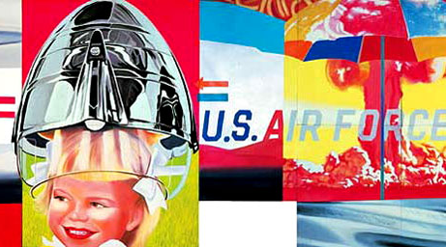
Light  Single and multiple light sources, dramatic high contrast or muted diffused light | 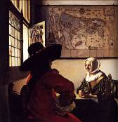
Linear Perspective  Single or dual vanishing points to which lines converge – creates the illusion of convincing three dimensional forms | 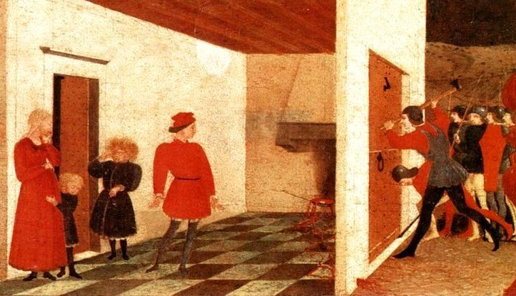
Local Colour  The true colour, unaffected by light, shade, distance, or reflection | 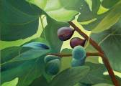
Media  Type of media used – oil, acrylic, watercolour, gouache, enamel, ink, vinyl, projection, etc | 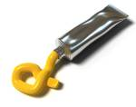
Monochrome  Single colour (Polychrome uses multiple colours) | 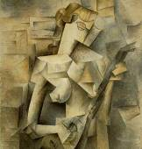
Multimedia  Combining different materials together | 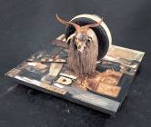
Narrative  Story, event, theme or sequence of events | 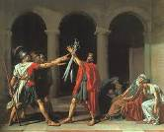
Naturalism  Rendering objects as they appear to be (as apposed to stylised or abstract) | 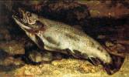
Negative Space  The empty areas between objects | 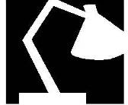
Post-Modern  Rejecting modernism – Multiple narrative and meanings, appropriation, irreverent, subversive, playful ironic, humorous, collage, montage, assemblage | 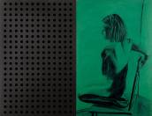
Pyramidal Composition  Arranging objects in a triangle or pyramid (3D triangle) to create a stable structure | 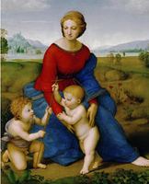
Repoussoir  Pictorial elements placed on the edges of the composition to force the viewers’ eye back into the picture | 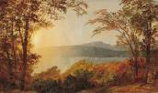
Scumbling  The process of passing a thin or broken layer opaque colour over other colour, so as not to cover it completely. With only a small amount of paint this can be referred to as Dry Brushing | 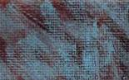
Sfumato  (Smokey) blurring of the edges of forms – used by Leonardo Da Vinci in the Mona Lisa | 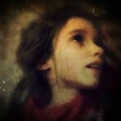
Staffage  Adding figures or animals into a painting (usually a landscape) | 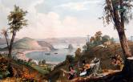
Stencil  Printmaking technique of cut out area through which paint is applied either with a brush or spray | 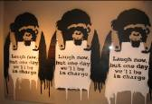
Stippling  Small touches, strokes, or dots, so as to obtain evenness of surface, gradation of shade, or intensity of shadow | 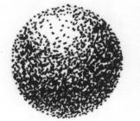
Stylised  Changing the appearance of the subject but still being recognisable - eg simplified, exaggerated or distorted | 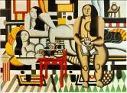
Symmetry  Balancing elements on either side of the centre line | 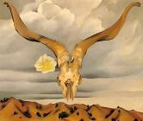
Trompe-l'œil  (French for "deceive the eye") Very convincing rendering and perspective where objects appear to emerge out of the picture plane | 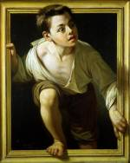
Tone  Bleached out pastel shades through to dark sombre mysterious shadows | 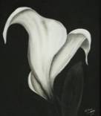
Transfer  Printing technique where the source image (Newspaper or photocopy) is transferred onto another surface | 