VENN DIAGRAM TASK: COMMUNICATING AND INTERPRETING IDEAS

Fill out the venn diagram below describing the difference and similarities between the work of Aaron Kereopa & Jess Santorik. You MUST DESCRIBE and PROVIDE EXAMPLES of the following features:

COLOUR, SCALE, SUBJECT MATTER, MATERIAL and TECHNIQUES.

**COMPARE & CONTRAST**

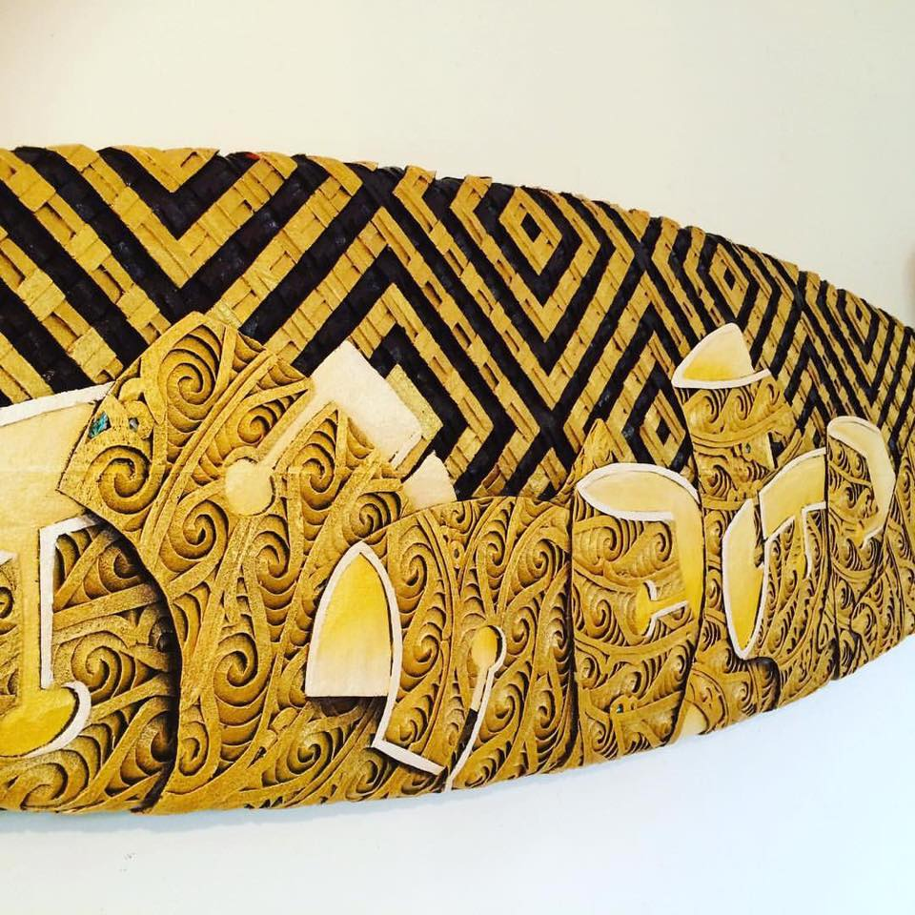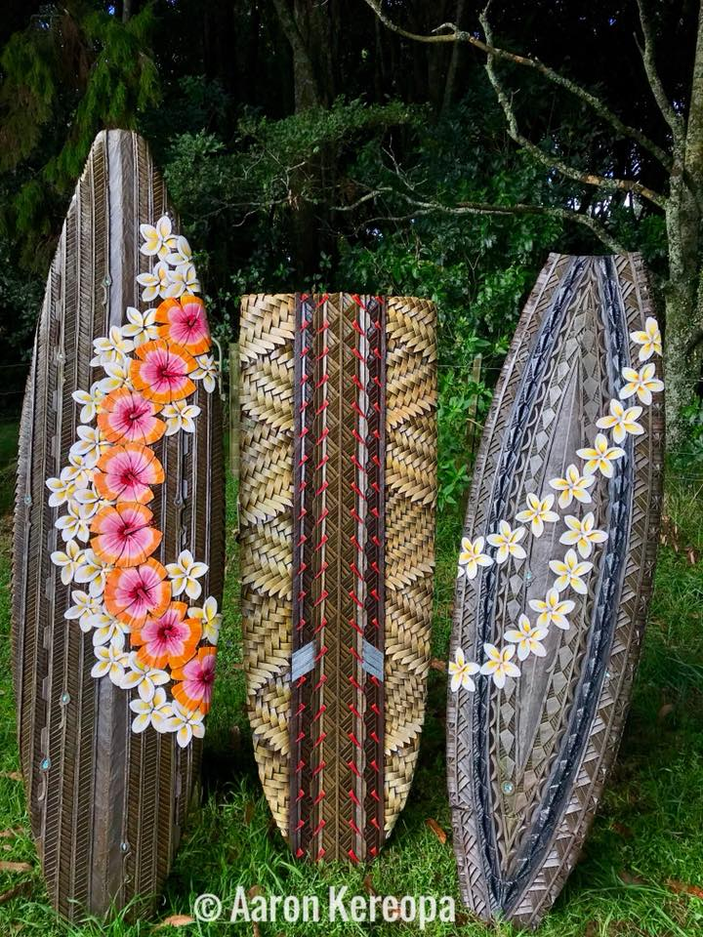

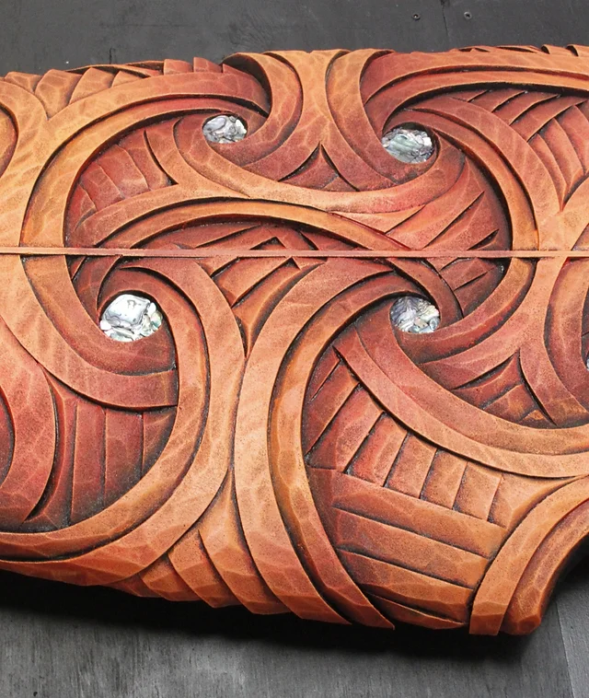

**Aaron Kereopa Jess Santorik**