| YEAR 10 PHOTOGRAPHY  **MAN RAY RESEARCH** |
| --- |

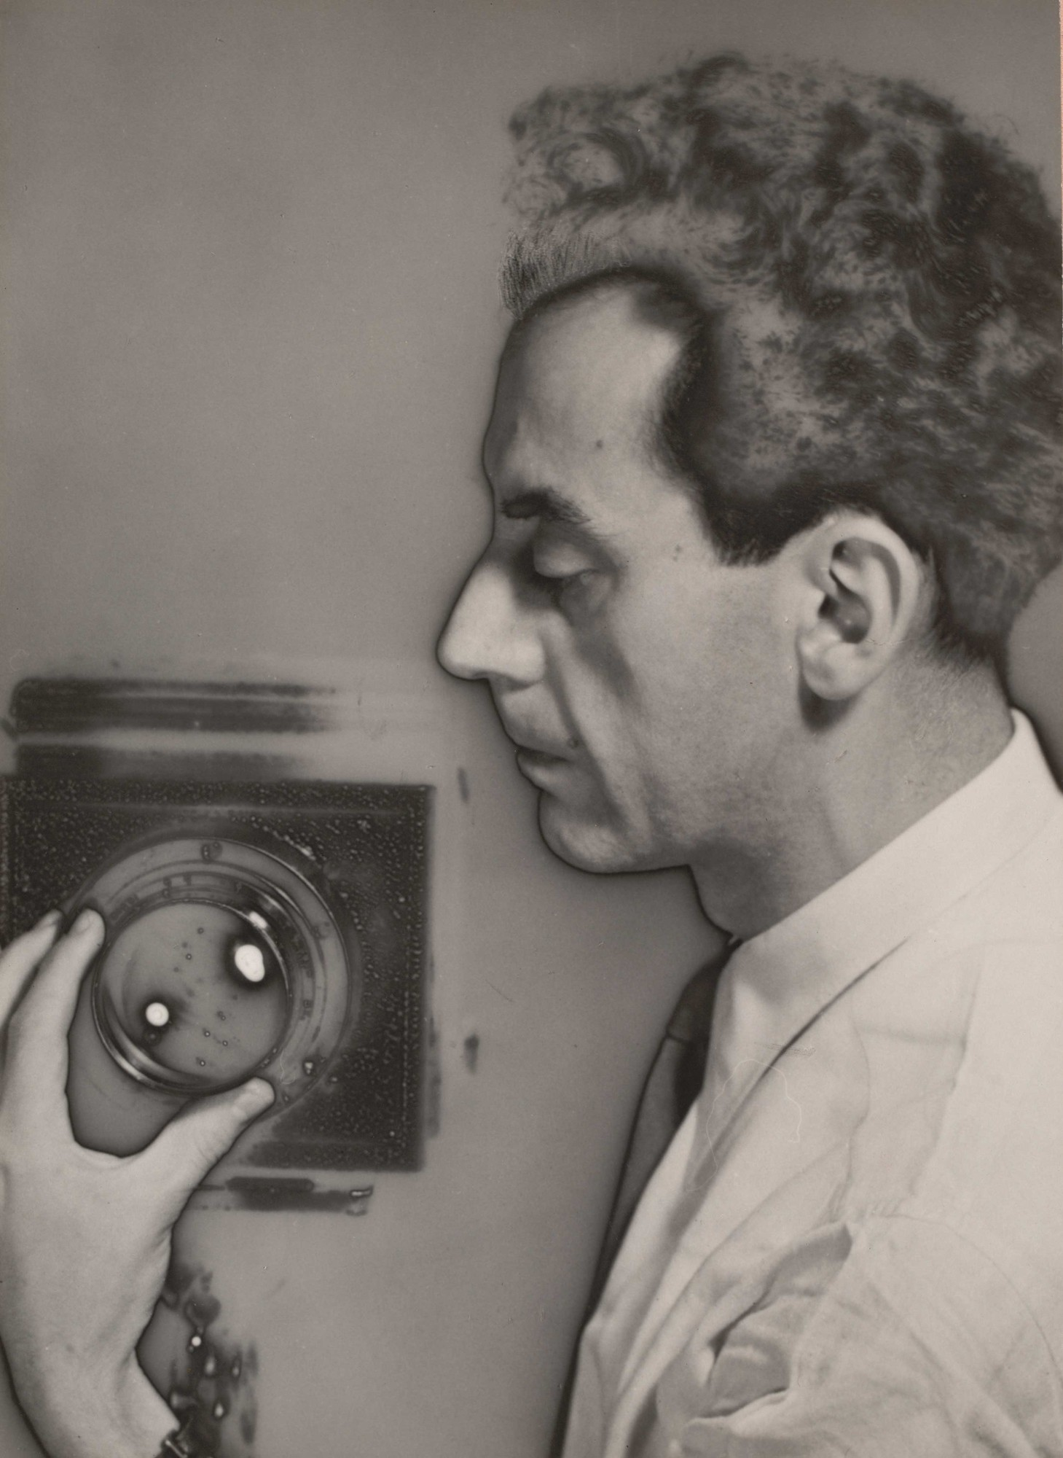

| LEARNING OBJECTIVES:   * Students are required to investigate **Man Ray** – Photograms and communicate their understanding of the ideas in his work. * Students are required to analyse and describe the composition (how the objects have been arranged) |
| --- |
| SUCCESS CRITERIA:   * Research Man Ray ( Photograms) * Analyze 4 of Man Ray Photogram works and their compositions. |
| **Task One - Research and Artist BIO** Read the following text and answer the questions. |
| **Man Ray**, born Emmanuel Radnitzky, was an influential American artist associated with the Dada and Surrealist movements in the 1920’s. He is particularly renowned for his innovative photograms, which he called "Rayographs." Created without a camera, Rayographs were made by placing everyday objects directly onto light-sensitive paper and then exposing them to light. This process resulted in abstract and surreal images that captured the essence of the objects' shapes and shadows. Man Ray began experimenting with this technique in the 1920s, driven by a desire to explore new artistic expressions and to challenge traditional photographic methods. His Rayographs often featured mundane items such as thumbtacks, coils, and other small objects, which he transformed into enigmatic and visually compelling compositions. This pioneering work not only expanded the boundaries of photography but also aligned with the avant-garde ethos of the Dada movement, which sought to disrupt conventional perceptions of art and reality. |
| **Answer the following questions:**  What is the artist’s name?  How do they make their artwork?  How did he rename Photograms ( what did he call them):  What are their works generally of?  Why do they make their work? What is it about?  Write a personal Statement about Man Ray, what are your thoughts about him. |

| **TASK TWO:**  Search on the internet and find THREE examples of Rayographs.  Identify and describe the subject matter and composition.  **Use the composition guide provided to help you.** | |
| --- | --- |
| Untitled, rayograph, 1922 | **Describe what you see in the Photograms (Subject matter)** |
| **Describe how they have been arranged (Composition)** |
| Feather and Matchboxes, 1923 | **Describe what you see in the Photograms (Subject matter)** |
| **Describe how they have been arranged (Composition)** |
| Untitled, rayograph, 1922 | **Describe what you see in the Photograms (Subject matter)** |
| **Describe how they have been arranged (Composition)** |